Introduction to the
MDI Client Portal

MDI Verify, Inc. dba Merlin Locate Services
2130 9Th St West, #323
Columbia Falls, MT 59912
855-321-4960
www.merlinlocate.com

Table of Contents

Introduction 2
Sending New Cases to MDI 3
The New Job Order Form 4
Case Management 9
Attaching Documents and Photos to the Case File 12
Accessing Your Report When the Job is Completed 13
The Case Notes Tab 14

Introduction
Welcome to the MDI Verify Client Portal! This web-based portal allows you to securely and privately submit all of your assignments to us; track the status of the assignments; send us notes, photos and documents and receive your final report.
If you currently send us your assignments in bulk (via spreadsheet), you will continue to use our secure ftp site to send us your requests. However, if you currently email, ftp or call-in your jobs you will now be able to submit your jobs directly to us through your portal. If you are on the road or unable to access your portal for any reason, you can still call in your jobs, however, in order to protect the privacy of your subject’s personal identifier information, we are no longer accepting jobs via email.
If you have not already received an email inviting you to our portal, give us a call or email our Office Manager, Kristin Hall at khall@mdiverify.com.

Mike Dores
Owner and Chief Investigator
MDI Verify, Inc. dba Merlin Locate Services
Montana PI License #9630
CA PI License #15087

The MDI Client Portal
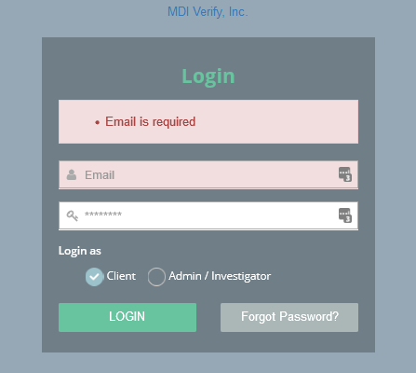
To access your client portal, follow the instruction in your “welcome” email and choose your password. Remember to login as a “Client”.

Sending New Cases to MDI
The first screen you come to is the Case Management Screen. To send a new case to MDI, click on Investigative Intake Form. You will be presented with the form shown below.
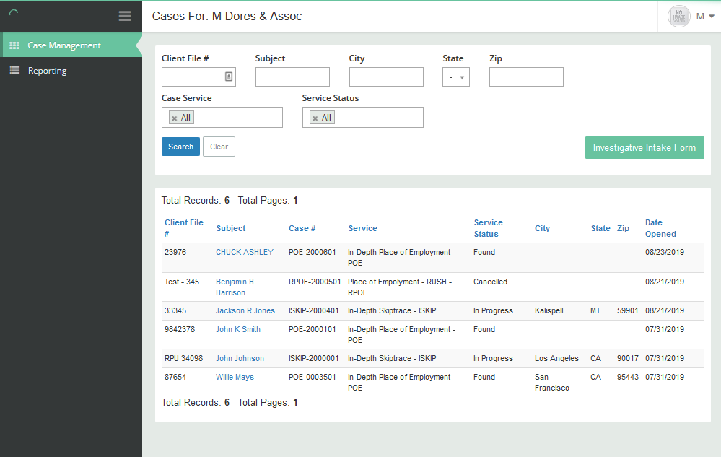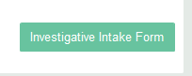

The New Job Order Form
Please fill out this form as completely as possible. The more information you provide about your subject, the better. Fields marked with * are required fields. See the following pages for detailed information pertaining to each section of this form.
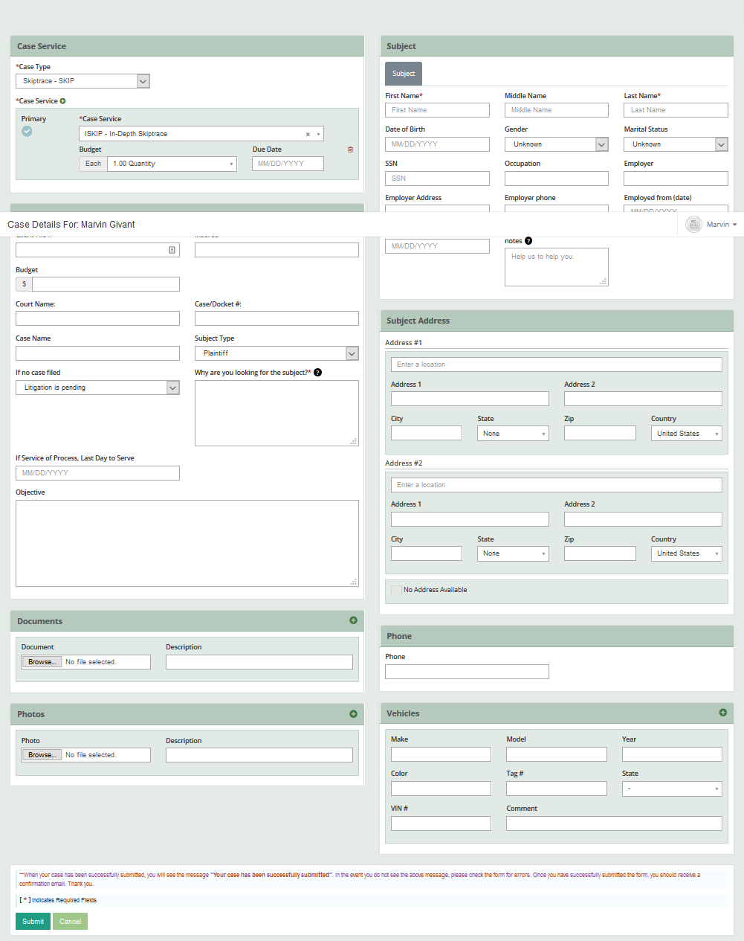
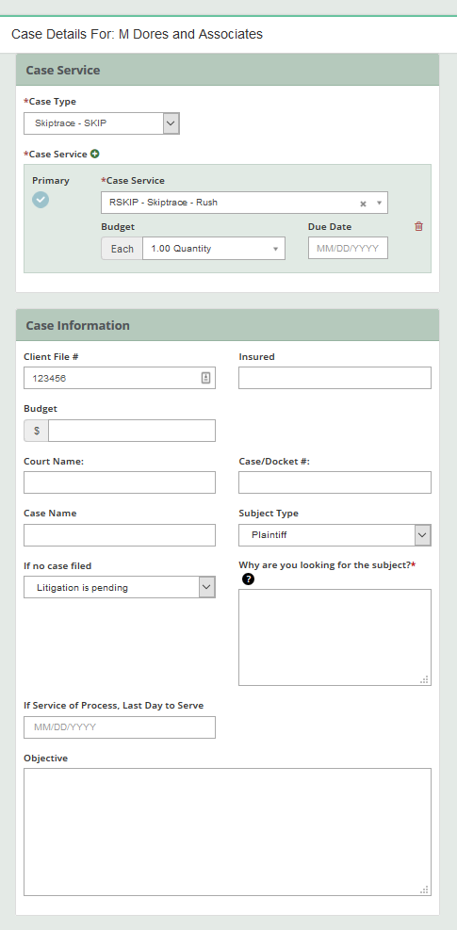
Case Service
Case Type: Choose either Skiptrace, Research, Place of Employments,
Banks or Other.
Case Service: Choose the specific type of investigation required. Click on the Down Arrow for a list of all available Case Services.
Due Date: Leave this field blank unless your Due Date is a hard date. Results are typically returned within 30 business days, depending on the volume of work in-house. All rush requests have a 7-day turnaround unless an earlier hard date is provided. s
Case Information
Fill in as many fields as possible.
“Why are you looking for the subject?*” is a required field.
The “Objective” field allows you to provide additional instructions. If you would like us to call you before starting the assignment, please make the request in the “Objective” field.
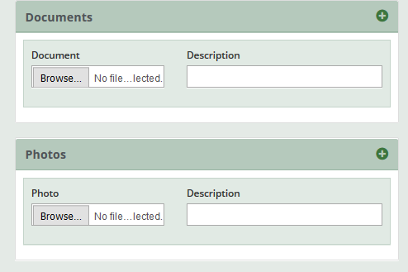
Documents
You can submit documents or photos along with your assignment. If your case involves service of process, please submit a copy of the documents to be served.
If you have run database searches on the subject, please provide the results to us.

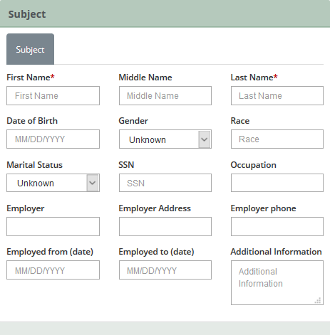
Subject Information
Please provide as much information as possible. Note that SSN is required for Place of Employment and Bank Searches and a current address is required for Bank Searches.
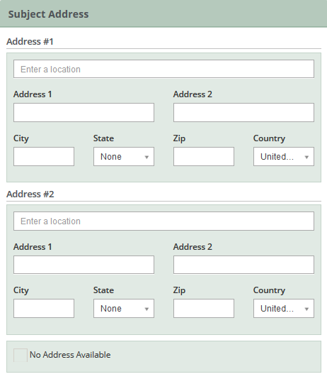
Subject Address
Please provide the two most recent addresses you have for the subject.
If you have an “Address History” list from a database provider, please attach that list as a document as described below.
If you have no address information for the subject, check the “No Address Available” box at the bottom of the box.

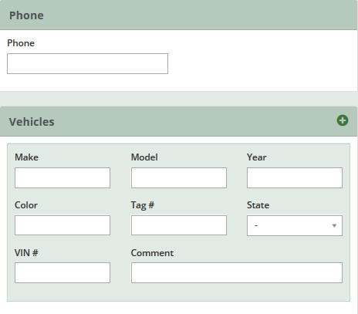
Phone and Vehicles
Please provide the most recent phone number you have for the subject. If you have additional phone numbers, enter that information in the “Additional Information” field in the Subject section.

Case Management
When you login, the first screen you come to is the Case Management Screen. You can also navigate to this screen from the menu on the left side of window. You will see a list of all cases you have ever submitted to MDI. You can filter the list by Client File #; Subject Name, City, State or ZIP; Case Service (job type) or Service Status. Placing the cursor in to the Case Service or Service Status box will show a list of all possible responses.
Note: This portal was created for a fictitious client called M Dores & Associates.

The screen below shows the results of a search for all cases with a Service Status of “Found”.

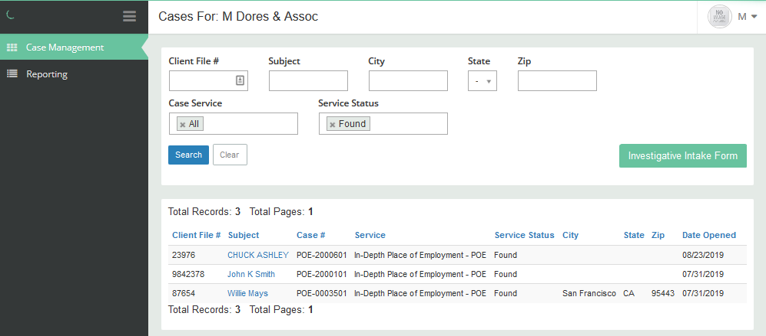

Clicking on the Subject Name will open the Case Detail Screen as shown below. This screen shows the information supplied by your office when submitting the job and the date the job was assigned to an investigator.
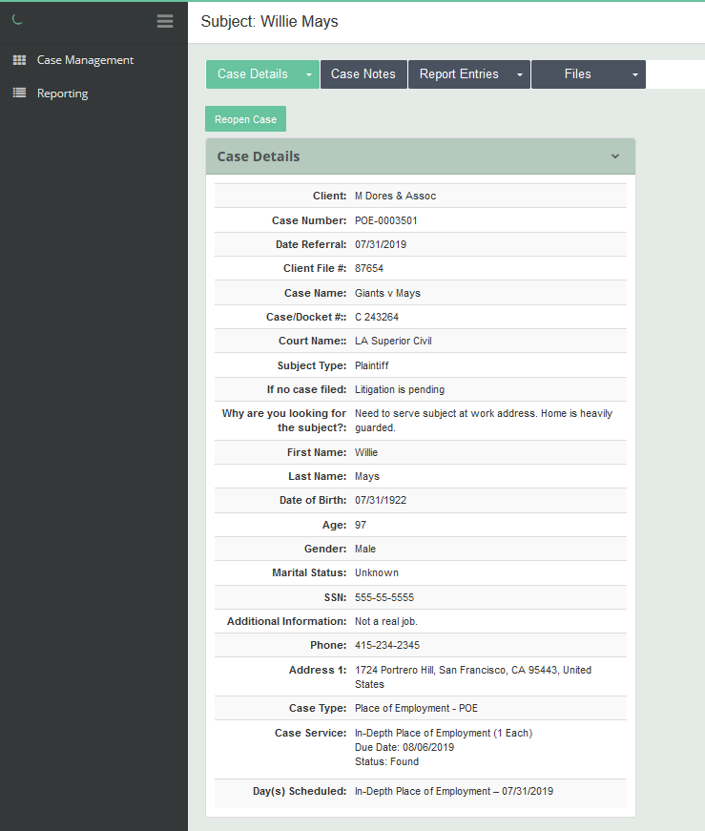

Attaching Documents and Photos to the Case File
Clicking on the Files Tab allows you to choose the type of file that has been associated with the case. These files may have been provided by your office when the job was submitted or after the job was submitted. It could also be a file provided by our office while working the job.
If you add a file to the case after it has been submitted, our office will automatically be emailed with a notification that the file has been added.

Accessing Your Report When the Job is Completed
When your job is complete, you will receive an email prompting you to retrieve the final report by clicking on Files>Documents.
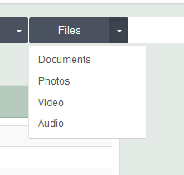
The Final Report for this case is available at the bottom of the page as shown on the next page.
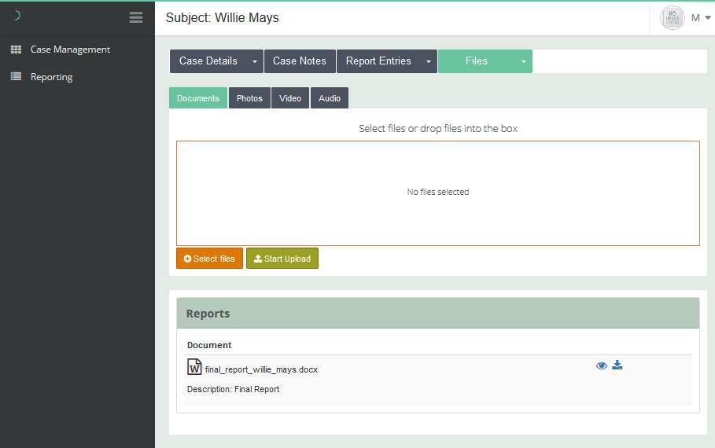
Click on this icon to download the file.
Click on this icon to see a preview of the file. You can download, save or print from this preview.

The Case Notes Tab
When MDI sends your office a status update on a case, you will receive an email with the status information. The status will also be available via the Case Notes tab. See the screen shot below.

